**Bug Report**

Summary: All the Brand Names are not listed in “Brand Name” filter sections

Priority = 2

Steps:

1. Login to Shipt and switch to Target store
2. Click “Browse”
3. Select “School and Office Supplies” category
4. Select “Printer and Ink” sub category
5. Verify the “Brand Names” section. It lists “Canon”, “Epson” and “HP”
6. Check “On Sale” flag

Actual Result: Noticed there are 3 items listed for Canon and HP Brand, but brand name section list only HP

Expected Result: Both “Canon” and “HP” should have been listed

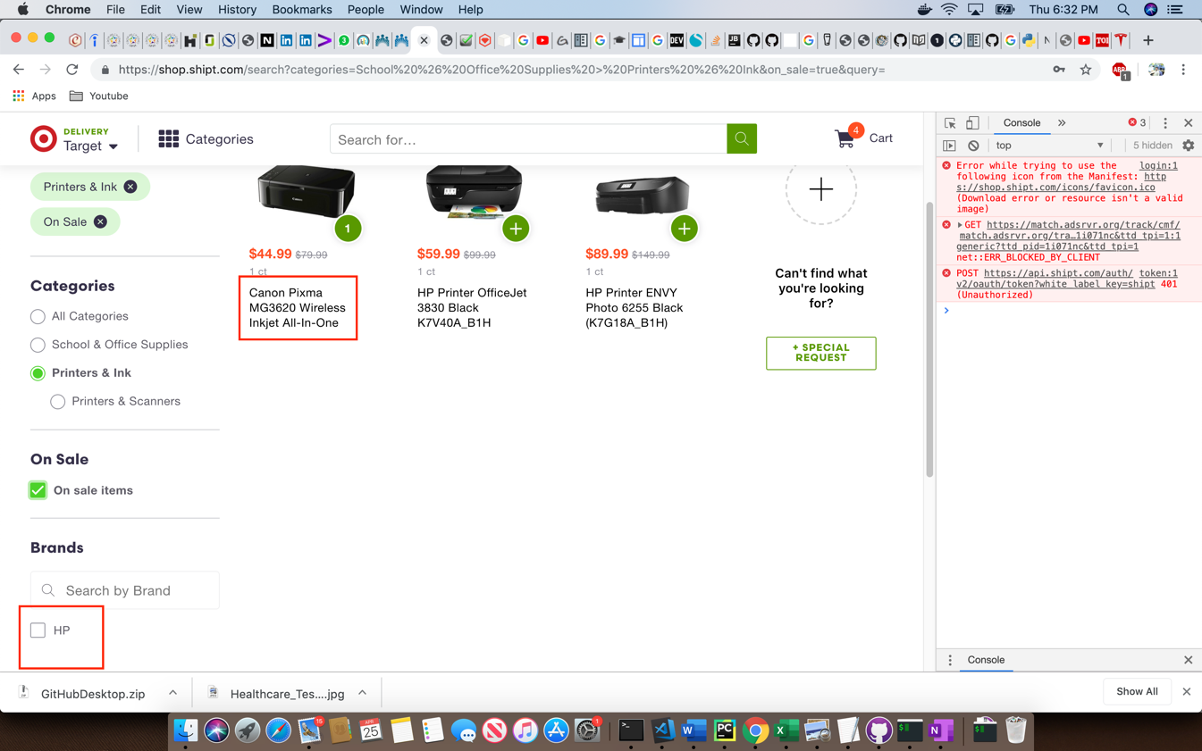

What are the possible reasons for the following defect? How would you go about debugging the problem and gathering more information?

This could be because the “Brand Name” field is missing in the backend. I notice that when filter items by “Canon” printer highlighted in the screenshot is not displayed which confirms the value missing in backend